Help Systems and Tutorials

**Table of contents**

1.Introduction 3

a.Welcome 3

2.Getting Started 3

a.System Requirements 3

b.Getting help (contact info of the developers or customer service) 3

3.Features 4

a.Navigation 4

b.Registering an Account 5

i.How to Log in 5

ii.Forgotten Password 6

iii.Change Password 6

c.Updating your Profile 7

d.Subscription 7

i.Checkout 8

ii.Payment confrimation 9

e.Post Hobby 9

4.Conclusion 9

**1.Introduction**

*Created with the Personal Edition of HelpNDoc:* [*Full-featured EPub generator*](https://www.helpndoc.com/create-epub-ebooks)

**a.Welcome**

The aim of this app is to bring like-minded people together and help people share or get help on their hobbies. We will enable two types of users: users who is willing to help and user who is looking for help with their hobbies.

Ex: I wish to learn guitar, I can look for people willing to teach me on the website.

*Created with the Personal Edition of HelpNDoc:* [*Easily create EBooks*](https://www.helpndoc.com/feature-tour)

**2.Getting Started**

*Created with the Personal Edition of HelpNDoc:* [*Write eBooks for the Kindle*](https://www.helpndoc.com/feature-tour/create-ebooks-for-amazon-kindle)

**a.System Requirements**

**Technologies:**

ReactJS,

MongoDB,

GitHub for version control or code management,

JavaScript,

HTML,

SCSS.

**Tools used:**

VS Code,

Mongoose,

Google Chrome

*Created with the Personal Edition of HelpNDoc:* [*Free EPub producer*](https://www.helpndoc.com/create-epub-ebooks)

**b.Getting help (contact info of the developers or customer service)**

1. Swagat Samal
2. Software Developer

Email: Ssamal@Conestogac.on.ca

1. Shubham Singh
2. Software Developer

Email: SSingh5808@conestogac.on.ca

1. Puneet Chopra
2. Software Developer

Email: Pchopra0250@conestogac.on.ca

*Created with the Personal Edition of HelpNDoc:* [*Easily create HTML Help documents*](https://www.helpndoc.com/feature-tour)

**3.Features**

*Created with the Personal Edition of HelpNDoc:* [*Easy EBook and documentation generator*](https://www.helpndoc.com)

**a.Navigation**

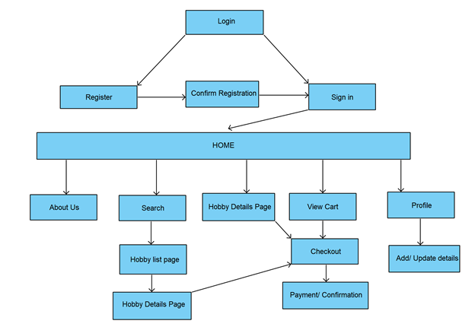

*Created with the Personal Edition of HelpNDoc:* [*Generate Kindle eBooks with ease*](https://www.helpndoc.com/feature-tour/create-ebooks-for-amazon-kindle)

**b.Registering an Account**

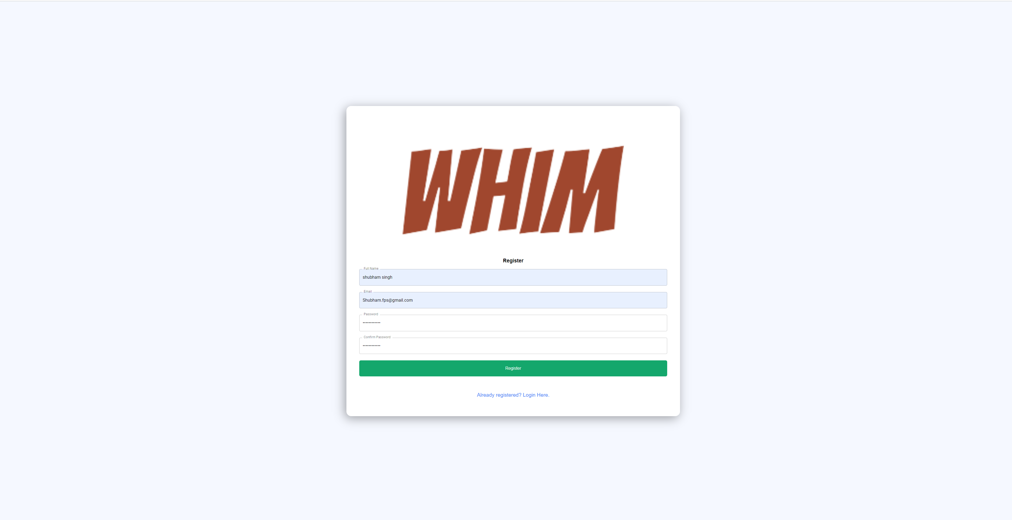

For registering a new user, form needs to be filled with the correct and validated input for successful registration.

*Created with the Personal Edition of HelpNDoc:* [*Free PDF documentation generator*](https://www.helpndoc.com)

**i.How to Log in**

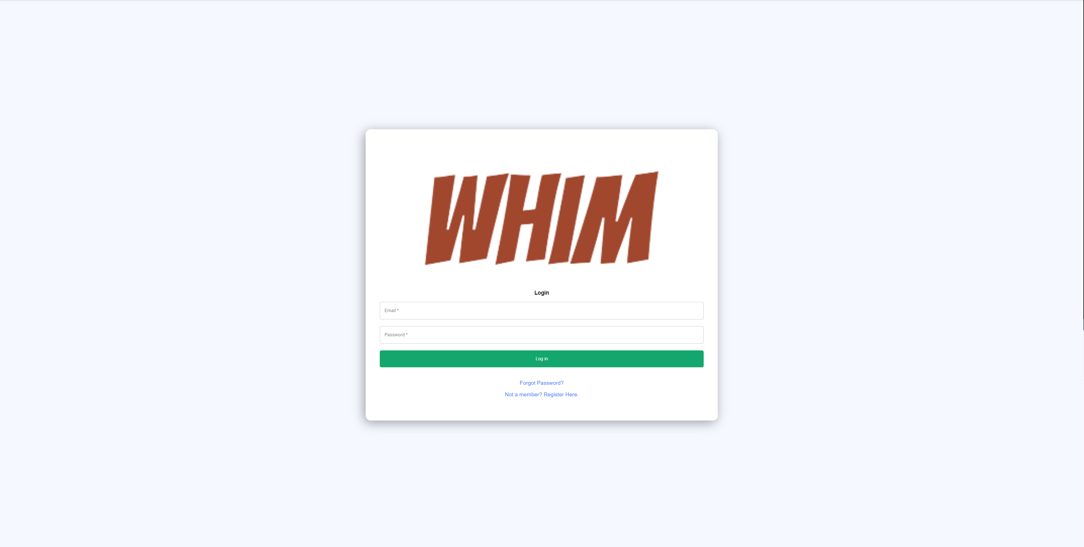

For login, user have to input registered credential.

*Created with the Personal Edition of HelpNDoc:* [*Easy EBook and documentation generator*](https://www.helpndoc.com)

**ii.Forgotten Password**

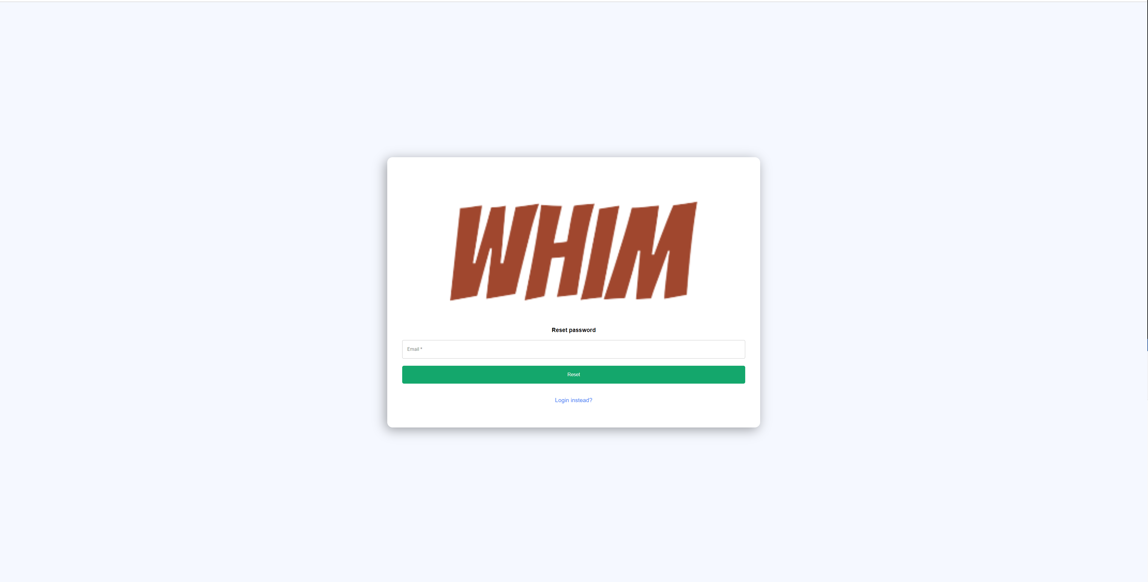

If a User forgets his/her password, user can reset their password by entering the registered email for which they want reset the password.

*Created with the Personal Edition of HelpNDoc:* [*Easy to use tool to create HTML Help files and Help web sites*](https://www.helpndoc.com/help-authoring-tool)

**iii.Change Password**

A reset link will be sent to registered email address:

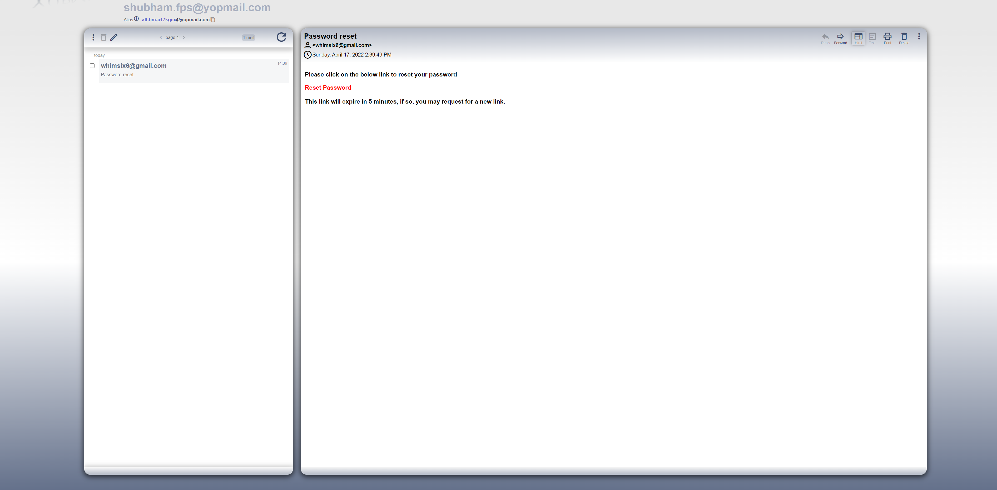

By clicking the reset password hyperlink it will take the user to update password page of the application.

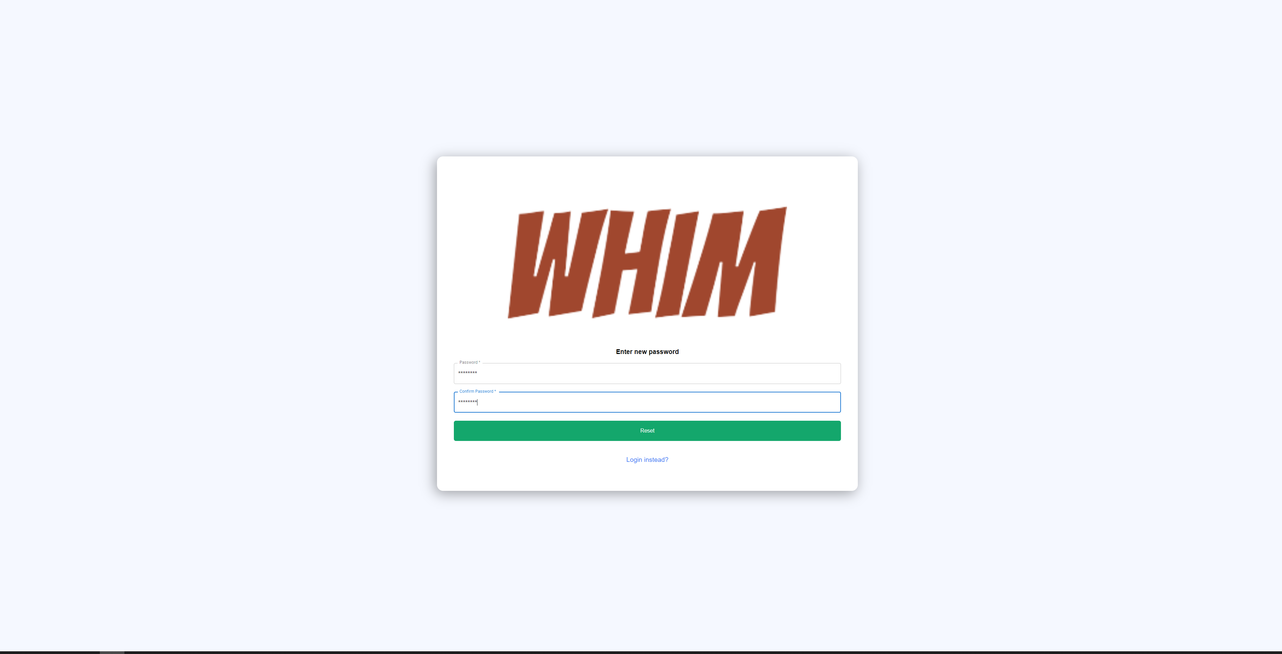

User can set the new password with the help of this feature.

*Created with the Personal Edition of HelpNDoc:* [*Easily create HTML Help documents*](https://www.helpndoc.com/feature-tour)

**c.Updating your Profile**

With the help of the My Account feature user can update his profile introduction, Description, Profile picture etc.

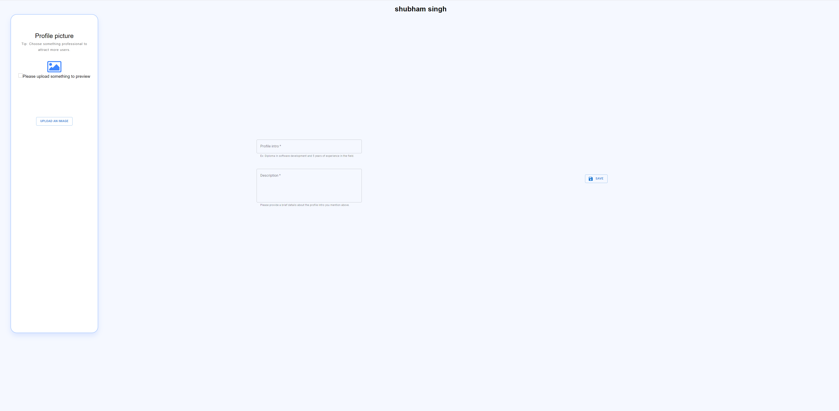

*Created with the Personal Edition of HelpNDoc:* [*Generate Kindle eBooks with ease*](https://www.helpndoc.com/feature-tour/create-ebooks-for-amazon-kindle)

**d.Subscription**

User can choose the subscription option from the list as per their choice.

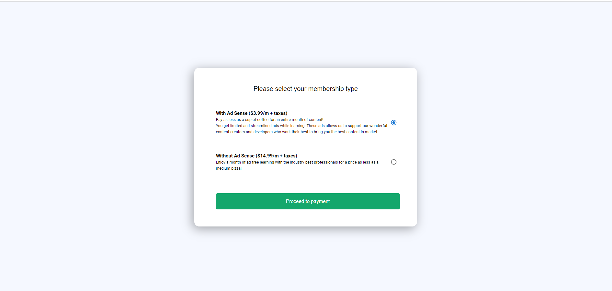

*Created with the Personal Edition of HelpNDoc:* [*Produce Kindle eBooks easily*](https://www.helpndoc.com/feature-tour/create-ebooks-for-amazon-kindle)

**i.Checkout**

User can checkout with the help of credit card payment

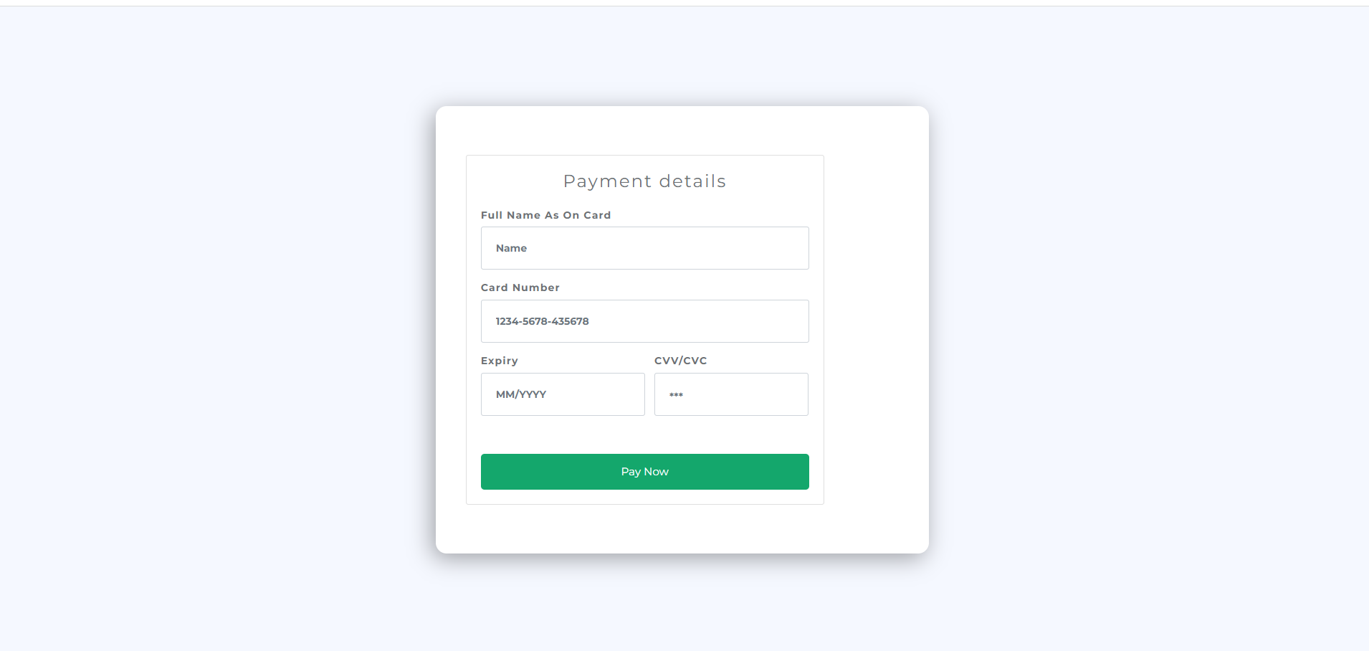

*Created with the Personal Edition of HelpNDoc:* [*Free Web Help generator*](https://www.helpndoc.com)

**ii.Payment confrimation**

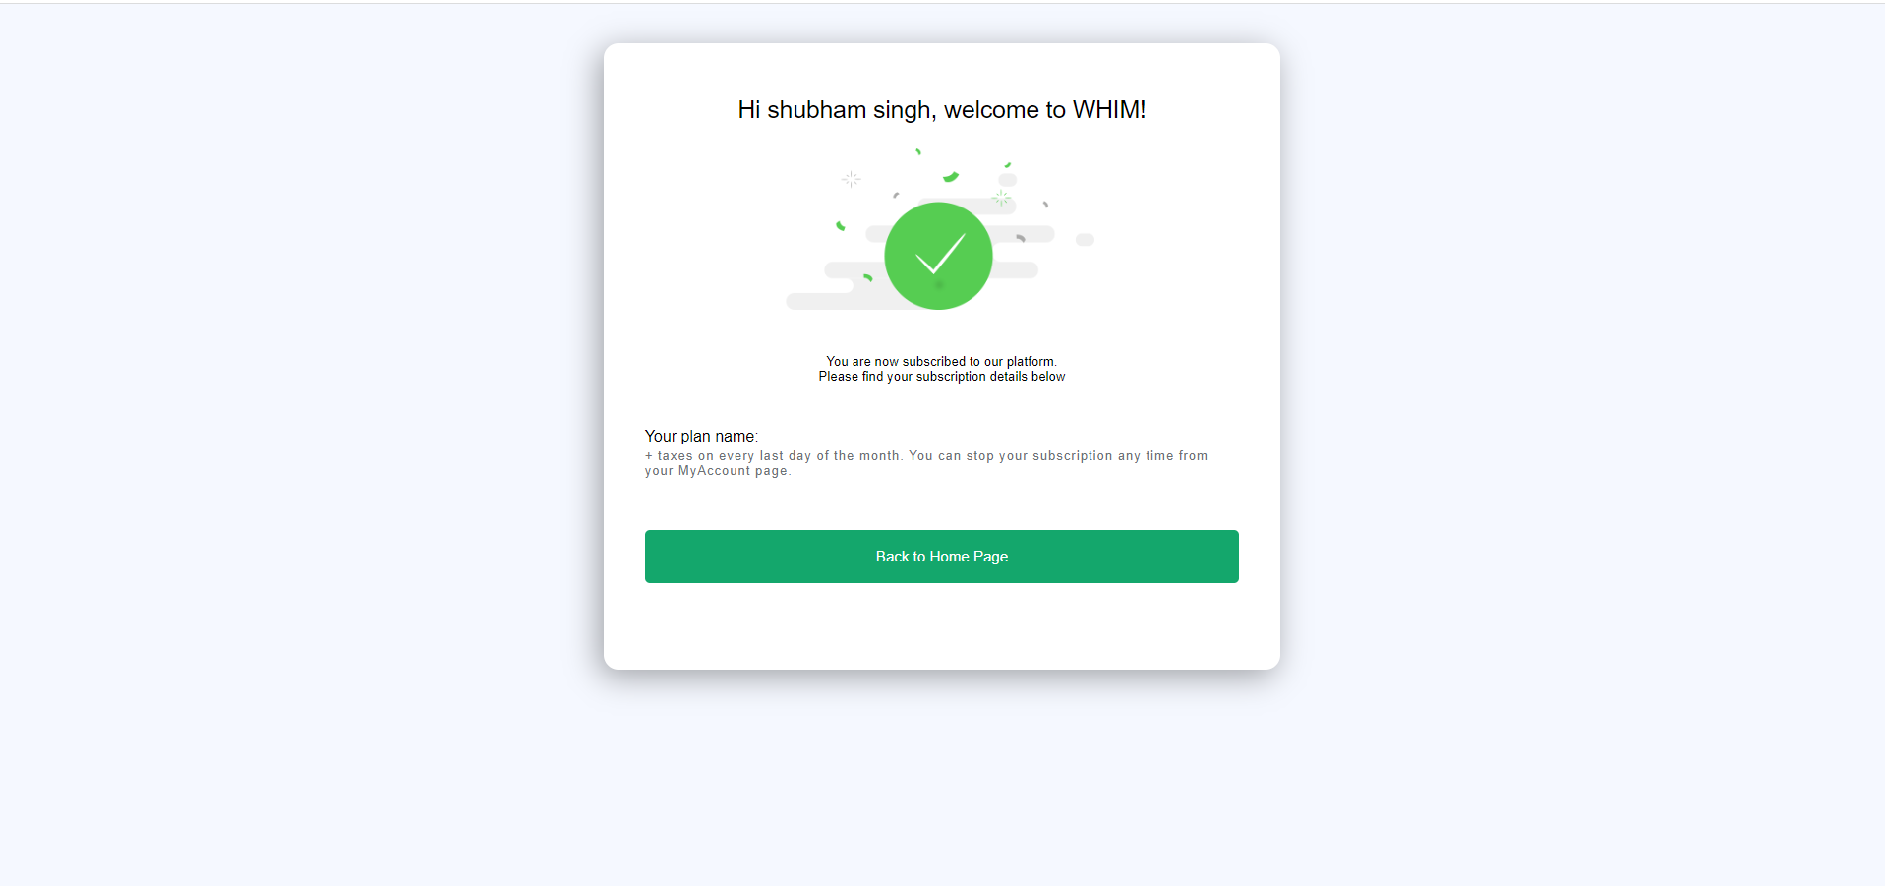

*Created with the Personal Edition of HelpNDoc:* [*Free Kindle producer*](https://www.helpndoc.com/feature-tour/create-ebooks-for-amazon-kindle)

**e.Post Hobby**

Author will have the option to post hobbies.

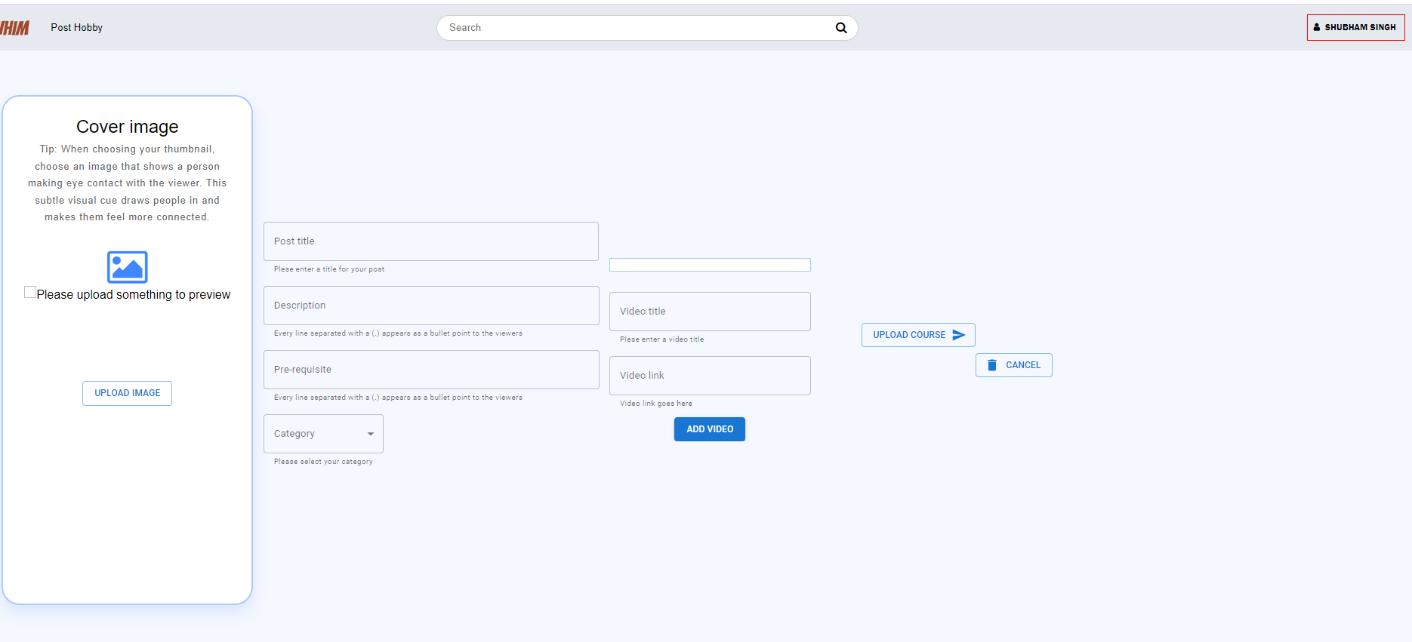

*Created with the Personal Edition of HelpNDoc:* [*Easy EBook and documentation generator*](https://www.helpndoc.com)

**4.Conclusion**

The best part of Whim, it will have a vast variety of content to target every age group. E-learning courses are always affordable than a physical book and is sustainable as it does not need paper or ink.

*Created with the Personal Edition of HelpNDoc:* [*Full-featured EPub generator*](https://www.helpndoc.com/create-epub-ebooks)